***EXAMPLE BRIEF****

Hello Friend,

We hope this email finds you doing well. We are reaching out to you today to request a testimonial for our business.

As one of our valued customers, your feedback means a lot to us. We would greatly appreciate it if you would being willing to make a video testimonial using the Lucihub platform. A testimonial from you would not only be a great way to showcase your satisfaction with our services, but it will also help others who are considering working with us.

We have two simple questions:

How was your experience with Lucihub?

What is the biggest challenge Lucihub has solved for you or your business?
Of course, you are welcome to include anything else that you feel is relevant or important.
To capture content:

- Hold iPhone vertically to shoot content
- Scan QR Code or click on project link [here] to upload video content, please be sure to have a strong Wi-Fi connection for uploads
- We kindly ask that all footage is uploaded by Friday, November 3rd by Noon PST.
- Click on the How to Film Yourself video for some tips on how to make your content look amazing.


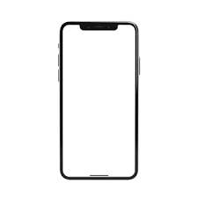

Thank you so much for your time and consideration. We truly appreciate your business and look forward to hearing from you soon.

Best regards,

Lucihub

